Arduino Ultrasonic Radar System Report

Introduction
This project is an ultrasonic radar system built using an Arduino, an HC-SR04 ultrasonic sensor, a servo motor, and a Python visualization interface using Pygame. The system scans the surrounding environment by rotating the ultrasonic sensor using a servo motor and displaying detected objects on a radar-style graphical interface.
The project combines embedded systems, serial communication, sensor interfacing, and computer graphics into one integrated system. It demonstrates how physical-world sensor data can be collected by a microcontroller and visualized in real time on a computer.
In simpler terms, the project acts like a miniature radar scanner. The ultrasonic sensor continuously measures distances while rotating across an angle range. The measured distances are transmitted to Python through serial communication, where the data is processed and displayed as radar targets on a graphical radar screen.
This project demonstrates the practical implementation of a simplified radar-inspired scanning system using affordable embedded hardware and software tools. The system integrates ultrasonic sensing, servo motor positioning, serial communication, and real-time graphical visualization to create an interactive environmental scanning platform.

Objectives
The major objectives of this project are:
- To interface an HC-SR04 ultrasonic sensor with an Arduino.
- To control a servo motor for angular scanning.
- To collect distance measurements from the environment.
- To transmit sensor data from Arduino to Python through serial communication.
- To create a radar-style visualization using Python and Pygame.
- To filter noisy sensor data for more reliable detection.
- To classify targets based on distance using color coding.
- To simulate a simple radar scanning system.

Components Used
Component | Description
Arduino Board | Main microcontroller used for sensor control and communication
HC-SR04 Ultrasonic Sensor | Measures distance using ultrasonic waves
SG90 Servo Motor | Rotates the ultrasonic sensor during scanning
Jumper Wires | Electrical connections between components
Breadboard | Temporary circuit assembly
USB Cable | Connects Arduino to computer
Computer Running Python | Handles radar visualization

Principle of Operation
The radar system works by combining rotational movement with ultrasonic distance measurement.
- The servo motor rotates the ultrasonic sensor from 0° to 180°.
- At each angle, the ultrasonic sensor measures the distance to the nearest object.
- The Arduino converts the echo time into distance.
- The Arduino sends angle and distance data to Python using serial communication.
- Python receives the data and converts the polar coordinates into screen coordinates.
- Targets are displayed as radar blips on the radar screen.
- Old detections gradually fade away to simulate realistic radar behavior.

Hardware Design

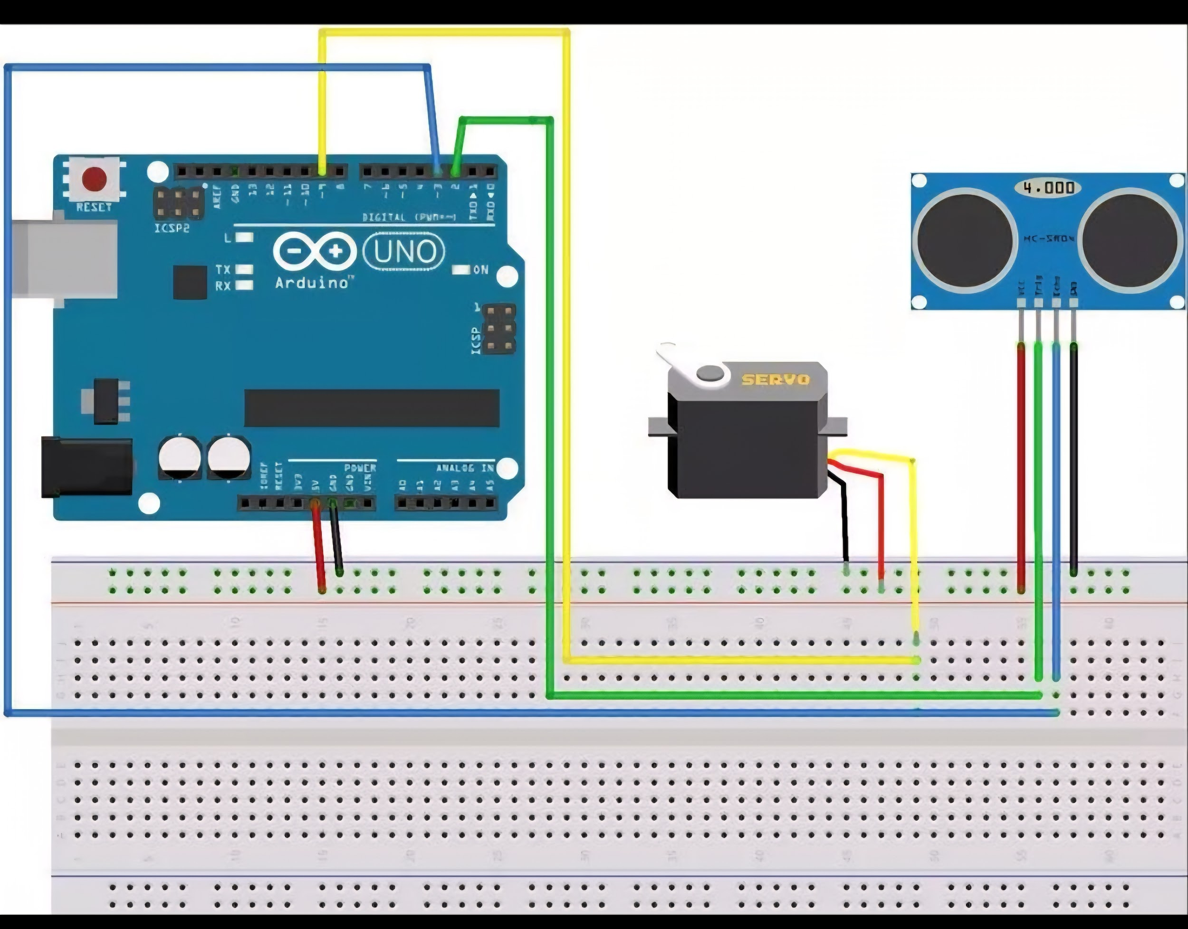

Ultrasonic Sensor
The HC-SR04 sensor operates using ultrasonic sound waves.
The trigger pin sends an ultrasonic pulse. The echo pin receives the reflected signal after bouncing off nearby objects.
Distance is calculated using:

\text{Distance} = \frac{\text{Time} \times \text{Speed of Sound}}{2}

The division by 2 is necessary because the sound travels to the object and back.

Sensor Connections
HC-SR04 Pin | Arduino Connection
VCC | 5V
GND | GND
TRIG | Pin 9
ECHO | Pin 10

Servo Motor
The SG90 servo motor rotates the ultrasonic sensor across different angles.

Servo Connections
Servo Wire | Arduino Connection
Red | 5V
Brown/Black | GND
Orange/Yellow | Pin 6
The servo sweeps continuously between 0° and 180°.
During testing, an issue occurred where the servo jittered but failed to rotate correctly. After troubleshooting:
- Multiple servos were tested.
- Multiple Arduino boards were tested.
- Code was verified.
- Power supply issues were checked.
The final issue was traced to a faulty jumper wire.
During testing and debugging, hardware connection faults were identified and corrected. This process highlighted the importance of reliable electrical connections and systematic troubleshooting in embedded systems development.

Arduino Software Design
The Arduino program performs the following tasks:
- Generates ultrasonic trigger pulses.
- Measures echo duration.
- Converts duration into distance.
- Controls servo angle.
- Sends angle and distance data through serial communication.

Distance Averaging
To reduce sensor noise, multiple readings are averaged.
This helps improve measurement stability.

Serial Communication Format
The Arduino transmits data in the format:
angle,distance

Example:
45,23.4

This format allows Python to easily separate angle and distance values.

Python Radar Visualization

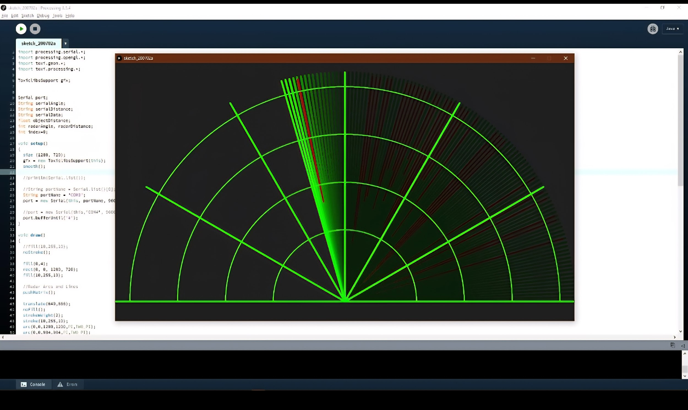
Python was used instead of Processing because:
- It is lightweight.
- It integrates well with Linux.
- Pygame provides flexible graphics support.
- Python offers easier customization.
The radar visualization includes:
- Radar circles.
- Rotating sweep arm.
- Persistent target blips.
- Fading target effects.
- Distance labels.
- Color-coded targets.

Radar Features Implemented

1. Real-Time Radar Sweep
The sweep arm rotates continuously according to the servo angle.

2. Persistent Radar Blips
Targets remain visible temporarily after detection instead of moving with the sweep arm.
This creates realistic radar behavior.

3. Fading Targets
Detected targets gradually fade out over time.
This simulates radar persistence.

4. Distance Labels
Each detected object displays its measured distance.
Example:
23.4 cm

5. Color Classification
Targets are color-coded based on distance.
Distance Range | Color
0 – 15 cm | Red
15 – 30 cm | Yellow
30 – 45 cm | Green
This improves readability and target awareness.

6. Detection Range Filtering
Although the sensor can theoretically detect up to 50 cm reliably in this setup, noisy readings near maximum range caused instability.
To solve this:
- A maximum reliable range of 45 cm was selected.
- Readings beyond 45 cm are ignored.
This reduced false detections.

7. Duplicate Blip Prevention
The software prevents multiple overlapping detections from appearing repeatedly in the same area.
This improves radar clarity.

8. Timed Blip Generation
New radar blips are created only once every second.
This prevents excessive clutter on the display.

Mathematical Concepts Used
Several mathematical concepts were used in the project.

Distance Conversion

\text{Distance} = \frac{\text{Duration} \times 0.0343}{2}

Where:
- Duration is the ultrasonic echo time.
- 0.0343 cm/μs is the speed of sound.

Polar to Cartesian Conversion
Radar measurements use polar coordinates.
To display points on the screen, coordinates are converted using trigonometry.

x = r \cos(\theta)

y = r \sin(\theta)

Where:
- is distance.
- is angle.

Challenges Encountered
Several technical issues were encountered during development.

1. Servo Motor Not Rotating

Symptoms
- Servo jittered during startup.
- Servo failed to sweep.

Solution
The issue was traced to a faulty signal wire.

2. Serial Port Errors

Error
Device or resource busy

Cause
The serial port was already occupied by another application.

Solution
- Closed Serial Monitor.
- Stopped conflicting processes.

3. Unicode Decode Errors

Error
UnicodeDecodeError

Cause
Random startup bytes from Arduino serial reset.

Solution
- Added startup delay.
- Cleared serial input buffer.
- Ignored invalid decode bytes.

4. Noisy Sensor Readings

Symptoms
- Readings fluctuated near maximum range.

Solution
- Reduced effective range from 50 cm to 45 cm.
- Added filtering logic.

System Workflow
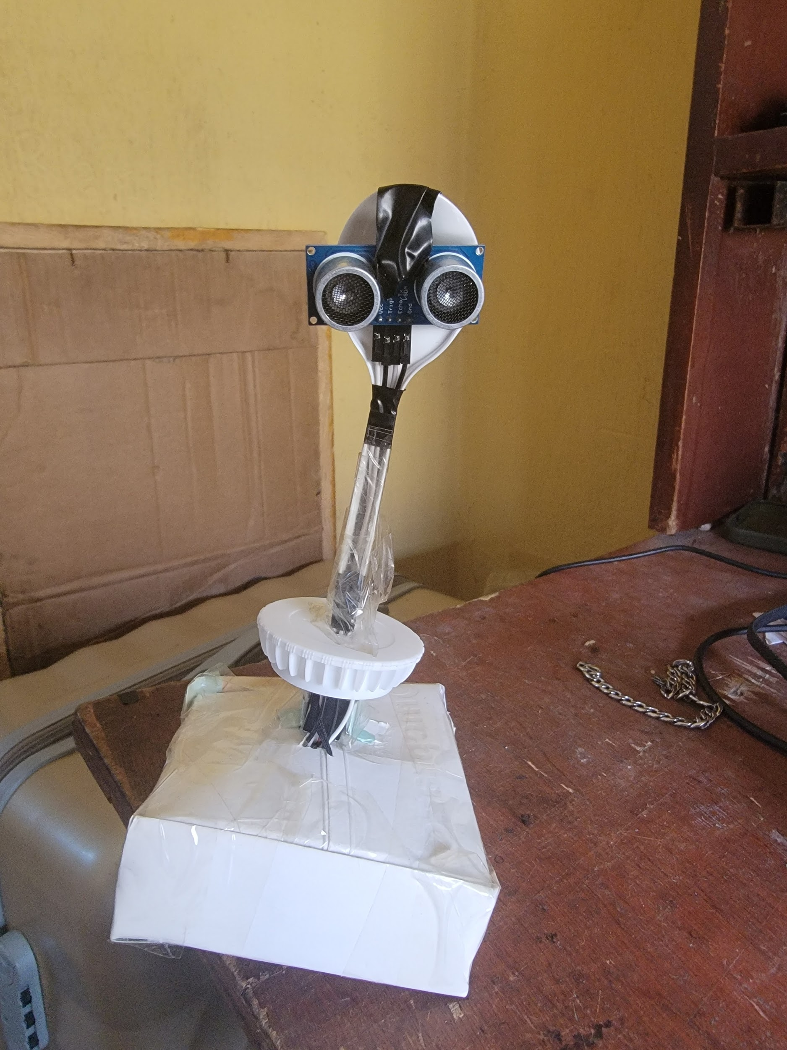
Ultrasonic Sensor
↓
Arduino Processing
↓
Serial Communication
↓
Python Data Processing
↓
Radar Visualization

This diagram helps explain the interaction between hardware and software components.

The overall system workflow is:
- Servo rotates sensor.
- Ultrasonic sensor measures distance.
- Arduino processes measurements.
- Arduino sends angle and distance through serial communication.
- Python receives serial data.
- Radar visualization updates.
- Targets are displayed and faded gradually.

Applications
Possible applications of this system include:
- Obstacle detection.
- Robotics.
- Autonomous navigation.
- Smart parking systems.
- Security systems.
- Motion detection systems.
- Educational demonstrations.
- Basic environmental scanning.

Possible Future Improvements
Several improvements can be added in future versions.

Hardware Improvements
- Higher quality ultrasonic sensors.
- 360° continuous rotation.
- External stable power supply.
- OLED integrated display.
- Multiple sensors.
- Wireless communication.

Software Improvements
- Target tracking.
- Radar trails.
- Glowing visual effects.
- Fullscreen interface.
- Object velocity estimation.
- Data logging.
- AI-based object classification.
- 3D radar mapping.
These future improvements would significantly enhance the system's capability, reliability, and visualization quality while expanding its practical applications in robotics and intelligent sensing systems.

Conclusion
This project successfully demonstrated the integration of electronics, programming, sensing, and visualization into a functional radar-style system.
The ultrasonic sensor and servo motor allowed the system to scan the environment, while Python and Pygame provided an effective graphical representation of detected objects.
Several engineering challenges such as sensor noise, serial communication errors, and hardware faults were identified and solved during development.
The project also demonstrated important engineering principles including:
- Sensor interfacing.
- Signal filtering.
- Real-time visualization.
- Hardware troubleshooting.
- Embedded systems communication.
- Coordinate transformation.
Overall, the project achieved its objectives and serves as a strong demonstration of practical mechatronics and embedded systems design.
The project also provided valuable practical experience in debugging, system integration, real-time processing, and embedded software development. It serves as an effective demonstration of the interdisciplinary nature of mechatronics engineering, combining electronics, programming, mathematics, and visualization into a unified working system.

Arduino Source Code
#include <Servo.h>
const int trigPin = 9;
const int echoPin = 10;
Servo radarServo;
float getDistance() {
long duration;
digitalWrite(trigPin, LOW);
delayMicroseconds(2);
digitalWrite(trigPin, HIGH);
delayMicroseconds(10);
digitalWrite(trigPin, LOW);
duration = pulseIn(echoPin, HIGH, 30000);
if (duration == 0) {
return -1;
}
float distance = duration * 0.0343 / 2.0;
if (distance < 2 || distance > 400) {
return -1;
}
return distance;
}
void setup() {
pinMode(trigPin, OUTPUT);
pinMode(echoPin, INPUT);
radarServo.attach(6);
Serial.begin(9600);
}
void loop() {
for (int angle = 0; angle <= 180; angle++) {
radarServo.write(angle);
delay(20);
float distance = getDistance();
Serial.print(angle);
Serial.print(",");
Serial.println(distance);
}
for (int angle = 180; angle >= 0; angle--) {
radarServo.write(angle);
delay(20);
float distance = getDistance();
Serial.print(angle);
Serial.print(",");
Serial.println(distance);
}
}

Python Source Code
import pygame
import serial
import math
import time
# =========================
# SERIAL SETUP
# =========================
ser = serial.Serial('/dev/ttyUSB0', 9600)
time.sleep(2)
ser.reset_input_buffer()
# =========================
# PYGAME SETUP
# =========================
pygame.init()
WIDTH = 800
HEIGHT = 800
screen = pygame.display.set_mode((WIDTH, HEIGHT))
pygame.display.set_caption("Arduino Radar System")
clock = pygame.time.Clock()
# =========================
# RADAR SETTINGS
# =========================
MAX_DISTANCE = 45
MIN_DISTANCE = 3
RADAR_RADIUS = 300
BLIP_INTERVAL = 1.0
DUPLICATE_DISTANCE = 20
# =========================
# RADAR VARIABLES
# =========================
angle = 0
distance = 0
blips = []
last_blip_time = 0
font = pygame.font.SysFont(None, 24)
running = True
# =========================
# MAIN LOOP
# =========================
while running:
for event in pygame.event.get():
if event.type == pygame.QUIT:
running = False
if ser.in_waiting:
try:
line = ser.readline().decode(errors='ignore').strip()
if "," in line:
angle, distance = map(float, line.split(","))
if MIN_DISTANCE <= distance <= MAX_DISTANCE:
scaled_distance = (
distance / MAX_DISTANCE
) * RADAR_RADIUS
rad = math.radians(angle)
x = WIDTH // 2 + scaled_distance * math.cos(rad)
y = HEIGHT - scaled_distance * math.sin(rad)
current_time = time.time()
if current_time - last_blip_time >= BLIP_INTERVAL:
duplicate = False
for blip in blips:
bx, by, brightness, dist, color = blip
dist_between = math.sqrt(
(x - bx) ** 2 +
(y - by) ** 2
)
if dist_between < DUPLICATE_DISTANCE:
duplicate = True
break
if distance <= 15:
color = (255, 0, 0)
elif distance <= 30:
color = (255, 255, 0)
else:
color = (0, 255, 0)
if not duplicate:
blips.append([
x,
y,
255,
distance,
color
])
last_blip_time = current_time
except:
pass
screen.fill((0, 0, 0))
center_x = WIDTH // 2
center_y = HEIGHT
pygame.draw.circle(
screen,
(0, 255, 0),
(center_x, center_y),
300,
1
)
pygame.draw.circle(
screen,
(0, 255, 0),
(center_x, center_y),
200,
1
)
pygame.draw.circle(
screen,
(0, 255, 0),
(center_x, center_y),
100,
1
)
pygame.draw.line(
screen,
(0, 100, 0),
(center_x - 300, center_y),
(center_x + 300, center_y),
1
)
pygame.draw.line(
screen,
(0, 100, 0),
(center_x, center_y),
(center_x, center_y - 300),
1
)
rad = math.radians(angle)
sweep_x = center_x + RADAR_RADIUS * math.cos(rad)
sweep_y = center_y - RADAR_RADIUS * math.sin(rad)
pygame.draw.line(
screen,
(0, 255, 0),
(center_x, center_y),
(sweep_x, sweep_y),
3
)
for blip in blips[:]:
x, y, brightness, dist, color = blip
r = min(color[0], brightness)
g = min(color[1], brightness)
b = min(color[2], brightness)
fade_color = (r, g, b)
pygame.draw.circle(
screen,
fade_color,
(int(x), int(y)),
6
)
distance_text = font.render(
f"{dist:.1f} cm",
True,
fade_color
)
screen.blit(
distance_text,
(int(x) + 10, int(y) - 10)
)
blip[2] -= 2
if blip[2] <= 0:
blips.remove(blip)
angle_text = font.render(
f"Angle: {angle:.1f}°",
True,
(0, 255, 0)
)
distance_text = font.render(
f"Distance: {distance:.1f} cm",
True,
(0, 255, 0)
)
screen.blit(angle_text, (20, 20))
screen.blit(distance_text, (20, 50))
pygame.display.update()
clock.tick(60)
ser.close()
pygame.quit()

